Investigation: The Equation of a Circle
Purpose: Determine the equation for a circle using coordinate geometry.

A circle with radius 10 and centre (0, 0) on a coordinate grid is show.

- A point is given on the circle with integral coordinates, A(6, 8). Draw the radius to point A.

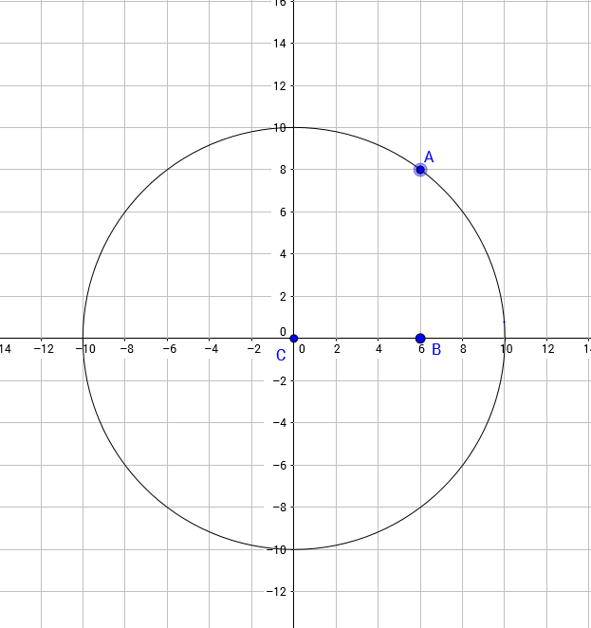

- Draw a vertical line segment AB to the x-axis and a horizontal segment BC, forming ΔABC.
- What is the measure of ∠CBA?

- Determine the length of each side of the triangle.

- Which side of the triangle is the radius? Label this side r.
- Write a formula relating the three sides of the triangle.

- Repeat steps A-C for point Q(-8, -6).

- Write an equation for the coordinates of ALL points satisfying a circle with the centre at the origin and a radius of 10.

- What is the radius of x2 + y2 = 256?

- What is the general equation of a circle?

Investigation Questions:
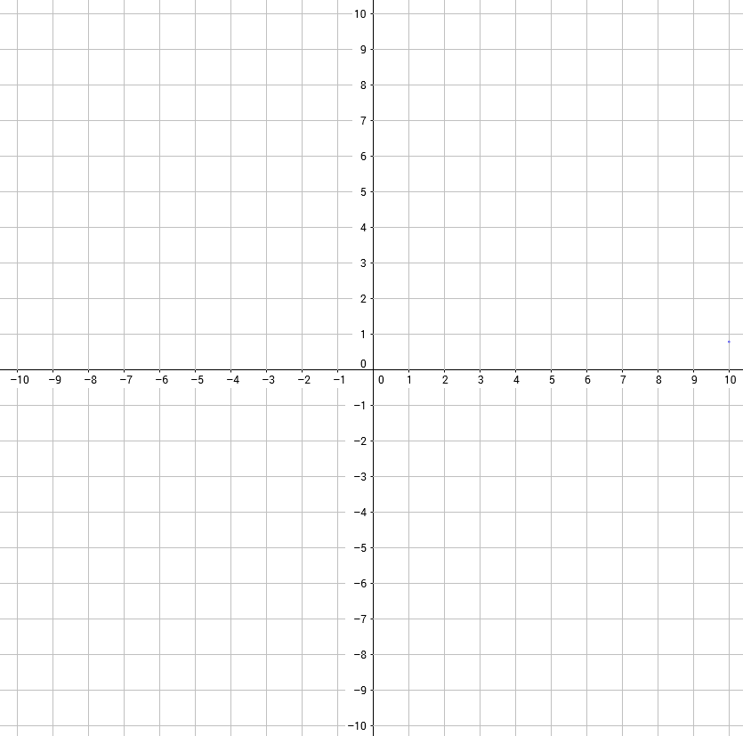
1. x2 + y2 = 49

What is the radius?

Sketch the circle.

Does the point (4, 5) lie on the circle?
If not, where does it lie? Justify.
Describe the circle with equation x2 + y2 = 49 in terms of a transformation of the unit circle, x2 + y2 = 1.

2. x2 + y2 = 64
What is the radius?

Sketch the circle.

Do the points Q(-4, 7) and R(0, -8) lie on the circle? Justify your answer.

Describe the circle with equation x2 + y2 = 64 in terms of a transformation of the unit circle, x2 + y2 = 1.

Write a mapping rule to express the circle as a transformation of the unit circle.

(x, y) →

Write a general mapping rule to express this kind of transformation of the unit circle.

(x, y) →

Investigation:Transformations of circles
Purpose: Examine circles under various transformations:
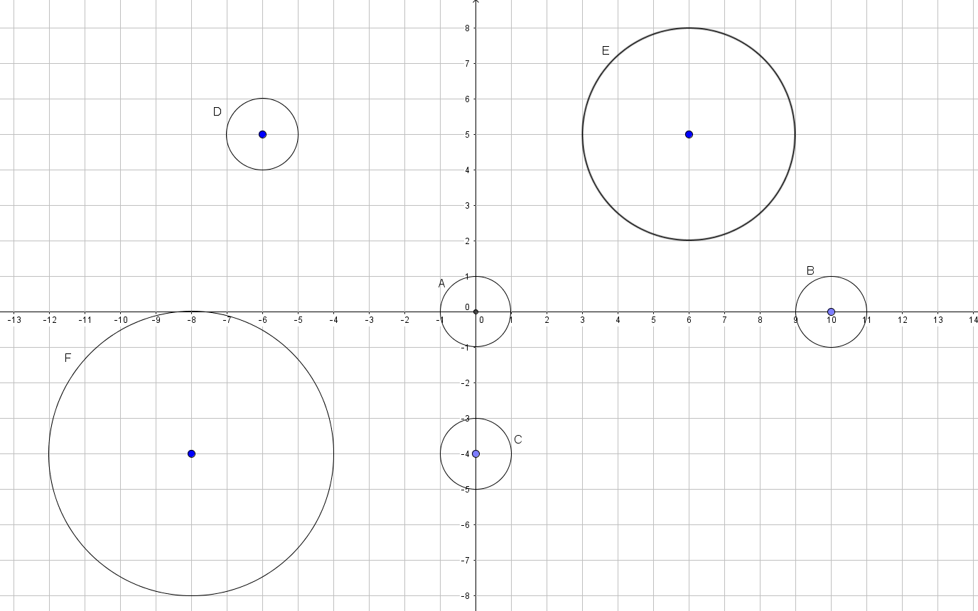

Procedure:
A: Write an equation for the unit circle “A”

Write the mapping rule of the unit circle.

B: How many units and in what direction has circle B shifted?

What are the coordinates of the centre of circle B?

Express circle B as a mapping of the unit circle.

The equation for circle B is (x – 10) 2 + y2 = 1.

C: How many units and in what direction has circle C shifted?

What are the coordinates of the centre of circle C?

Express circle C as a mapping of the unit circle.

Write the equation of circle C.

D: How many units and in what direction has circle D shifted?

What are the coordinates of the centre of circle D?

Express circle D as a mapping of the unit circle.

Write the equation of circle C.

E: What is the radius of circle E?

How many units and in what direction has circle E shifted?

What are the coordinates of the centre of circle E?

Express circle E as a mapping of the unit circle.

Write the equation for circle E.

F: What is the radius of circle F?

How many units and in what direction has circle F shifted?

What are the coordinates of the centre of circle F?

Express circle F as a mapping of the unit circle.

Write the equation for circle F.

F: Write a general mapping rule for circles as mappings of the unit circle with centre (h, k).

Write a general equation for a circle with centre (h, k).

G: What is the centre and the radius of (x – 12) 2 + (y + 7) 2 = 2

Transformations of Circles

Centre (h, k), radius = r Standard For m: (x – h) 2 + (y – k) 2 = r2
2 2

Transformations Form:
⎡1 (x − h)⎤
+ ⎡ 1 (y − k )⎤ = 1

⎣ r ⎦ ⎣ r ⎥
⎢
⎢
⎥
⎦
(x, y) → (rx + h, ry + k)
h.s. = r v.s. = r
h.t. = h v.t. = k

(x, y) → (ax + h, by + k)

